FOUND POETRY
What is it?
A “found poem” is poetry created by taking words and phrases from other sources and reframing them by making changes in spacing or lines to create new meaning.
How do I make it?
- Read the entire excerpt carefully.
  - Use a dictionary (or your phone) to look up words that you don’t understand
  - Discuss what the excerpt means as a match.
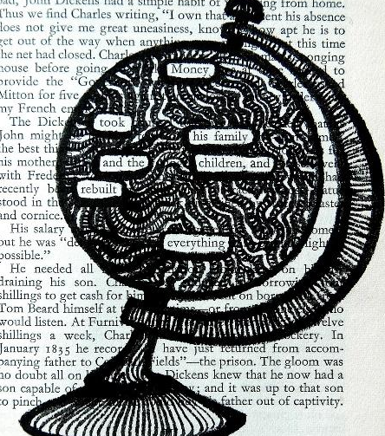
- Mark any words and phrases that are particularly powerful, moving, or interesting to you.
- Look at the words/phrases you have chosen and decide on some themes or a message for your poem.
- Draw a box around the words and phrases you want to use.
- Cross out all of the words you are not using. You can draw a picture or use different colors to block the extra words out, like the example to the right.

Tips and Tricks:
- If you’re having trouble making your poem “flow”, write the words down on a separate sheet of paper and rearrange them however you’d like. You do not have to keep the words in the order they came – although it is fun to try!
- Add prepositions (to, of, about, for) and articles (a/an, the) if necessary.
- Add a “poet’s statement” to your poem. This can help the audience better understand your message.
- Poems can be ANY length. Even if you just have a few words, as long as they have meaning together they can be a poem.

