ENCOURAGEMENT FOLDERS
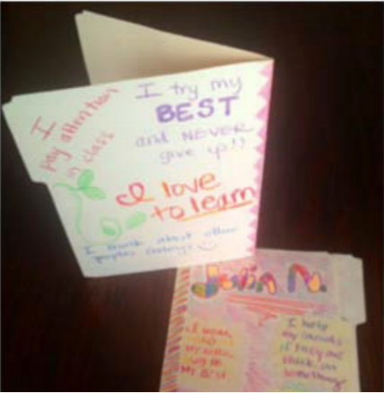
Optimistic thinking is an attitude of confidence, hopefulness, and positive thinking regarding life situations in the past, present, and future. To help build your Little’s optimistic thinking, create an Encouragement Folder for your Little. On the outside write encouraging phrases, put-ups, etc. that you have recognized about your Little. On the inside, fill the folder with pictures from your match outings and things you like to do together, such as coloring pages, then give the folder to your Little when you meet again in person. Your Little can then add to it, writing their own encouraging statements about themselves on the outside of the folder and adding to the content on the inside. Encourage others in your Little’s life to add to the folder, as well.
When thinking of phrases to choose, when in doubt choose specificity over generality.
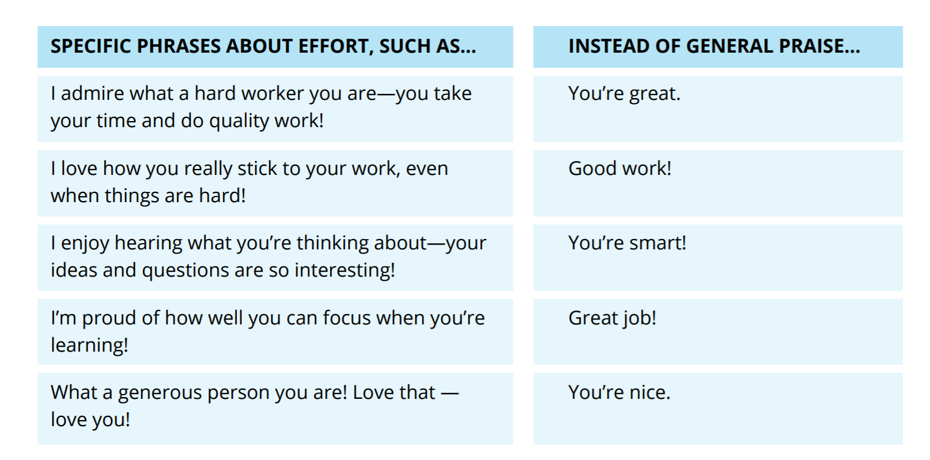
Schedule regular times during for you and your little to pull out their Encouragement Folders and take a couple minutes during your match outings to allow your Little to remind themselves of what they and others wrote.
Your Little is learning to stop, take a breath, and then make a decision about how they want to think and act in stressful or challenging situations. When they repeat this same pattern of noticing, naming, and reframing, their brains actually build and strengthen new neural pathways. Helping our children recognize their feelings and control their attitudes gives them a head start toward being well-grounded and confident people.

